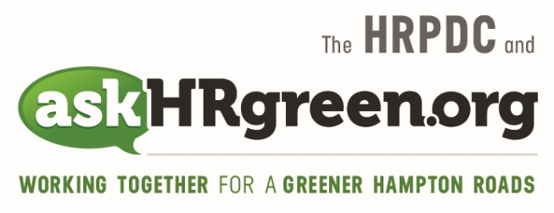

Media Contacts:
Katie Cullipher, HRPDC Principal Environmental Education Planner
(757) 420-8300; kcullipher@hrpdcva.gov
Christina Trapani, Keep It Beachy Clean, Program Coordinator
(757) 613-5683; beachycleanvabeach@gmail.com

Regional Green Groups Invite Hampton Roads Restaurants
To Make it a “Straw-free Earth Day,” April 22
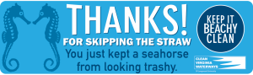
(Hampton Roads, Va., April 5, 2019) – Sunny skies and sizzling days are just around the corner; prime time for chilling out with an ice-cold beverage at a favorite coffee shop, sidewalk café or restaurant. To encourage Hampton Roads restauranteurs to serve those frothy drinks without the ubiquitous plastic straw, two regional green groups have set their sights on local restaurants as the focus of a “Straw-free Earth Day” event, April 22.
Sponsored by Keep It Beachy Clean and askHRgreen.org, the one-day campaign will raise awareness about the environmental effects of single-use plastic straws, ranked among the Top 10 most littered items by The Ocean Conservancy.
“Plastic straws are made of material that is designed to last for decades, yet they are generally used for less than 30 minutes and then thrown away,” said Christina Trapani, program manager for the Keep It Beachy Clean program. “Straws that enter our waterways can break up into smaller pieces over time, persisting for years, endangering sea turtles, birds and other marine life that can mistake them for food.”
Targeting the region’s restaurant community, the event organizers are inviting eateries to fill out an online form at www.keepitbeachyclean.org/strawfree, where they can request window clings, tabletop signs and social media graphics with messages such as: “Thanks for skipping the straw. You just kept a seahorse from looking trashy.” Participating dining establishments will be featured on the websites of both organizations.
For diners who simply can’t go without, participating restaurants will be supplied with a sample of paper straws to offer. While paper straws are a much better alternative than plastic, the best alternative is that restaurants use the Keep It Beachy Clean materials for a future straws-on-request policy.
The “Straw-free Earth Day” message is just fine with Katie Cullipher, who oversees askHRgreen.org, a region-wide public awareness and education campaign administered through the Hampton Roads Planning District Commission.
“The campaign fits nicely with our ‘Choose to Refuse Single-use Plastics’ initiative,” said Cullipher. “Saying ‘no’ to plastic straws, utensils, grocery bags, coffee stirrers and polystyrene to-go containers may be the single most important thing you can do to reduce plastic in our oceans, litter on our streets, dangers to wildlife, and landfills filled to the brim.”
In addition to inviting restaurants to ditch the straws on “Straw-free Earth Day,” Trapani encourages individuals to opt out as well, by taking an online pledge, letting servers know they don’t want a straw, or bringing their own reusable sipper.
“If you can, bring your own reusable straw or just go without it,” said Trapani, “and enjoy your drink while you help Keep It Beachy Clean!”

About Keep It Beachy Clean Keep It Beachy Clean is a program of Clean Virginia Waterways of Longwood University. The Virginia Beach Resort Advisory Commission’s G.R.E.E.N. Committee serves as the advisory committee to the Keep It Beachy Clean Program. See a list of our 2018 sponsors, partners and participants. Please help support Keep It Beachy Clean by donating to Clean Virginia Waterways here. Find Keep It Beachy Clean on Facebook Twitter and Instagram for all the latest updates on Straw-Free Earth Day!

About askHRgreen.org askHRgreen.org is your go-to resource for all things green in Hampton Roads – from recycling tips and pointers for keeping local waterways clean to water-saving ideas and simple steps to make local living easy on the environment. Launched in 2011, the region-wide public awareness and education campaign is administered through the Hampton Roads Planning District Commission and powered by the following members: The cities of Chesapeake, Franklin, Hampton, Newport News, Norfolk, Poquoson, Portsmouth, Suffolk, Virginia Beach, and Williamsburg; the counties of Gloucester, Isle of Wight, James City, Southampton, Surry and York; the town of Smithfield; and HRSD. Like askHRgreen.org on Facebook, follow on Twitter and Instagram, tune in to YouTube and catch the “Let’s Talk Green” blog, written by a team of local experts.

