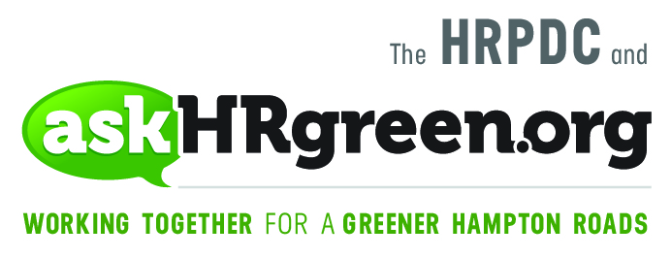

Media Contacts:
Katie Cullipher, HRPDC Principal Environmental Education Planner
(757) 420-8300; kcullipher@hrpdcva.gov
Elizabeth Evans, Red Chalk Studios
(757) 705-7153; elizabeth@redchalkstudios.com

Calling All Hampton Roads Businesses,
Community Groups and Neighbors!
Organize Now for the Great American Cleanup, May 3-4
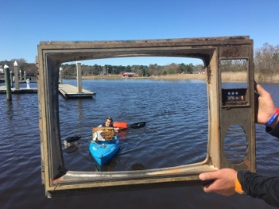
(Hampton Roads, Va., Feb. 20, 2019) – The Earth Mother of all cleanup events is a few months away, but askHRgreen.org and Keep Virginia Beautiful are encouraging businesses, community groups and neighbors to identify cleanup sites and organize now in advance of the Great American CleanupTM launch, May 3-4 in Hampton Roads.
An annual Keep America Beautiful initiative, the Great American Cleanup is the nation’s largest community improvement program designed to end littering, improve recycling and beautify America’s communities. The Hampton Roads region, backed by the 17 cities and counties that power askHRgreen.org, has had a strong presence in the campaign for many years. Once again, cleanup events are planned across the region this spring, with the two-day National Kickoff to the Great American Cleanup planned for May 3-4 in partnership with Keep Virginia Beautiful.
“We’re thrilled to be partnering with Hampton Roads communities on this event,” said, Keep Virginia Beautiful Executive Director Mike Baum, whose office is working closely with askHRgreen.org to coordinate the two-day cleanup drive. “The launch of this year’s Great American Cleanup will involve hundreds of local volunteers transforming local parks, waterways and recreational areas into cleaner, greener environments. We hope everyone will pick a project and get involved.”
The Hampton Roads cleanup events will begin Friday, May 3 in the morning with corporate and military command teams working side-by-side with local volunteers to perform cleanup projects at community-based sites throughout the region. On Saturday, May 4, more volunteer teams will mobilize and disperse to pitch in with cleanup and beautification events held throughout the region.
Team Up 2 Clean Up
Over the past several months, askHRgreen.org team members have coordinated with the region’s municipalities to identify “transformational” community improvement projects with an eye toward turning local parks, playgrounds and public spaces into greener, more sustainable places to live, work and play.
The idea, according to Regional Project Chairman Wayne Jones, is to connect Hampton Roads volunteers with projects that will be meaningful to their community. In addition, community and environmental leaders may submit requests for new sites to add to the list.
“Depending on the cleanup site, we will need 25 or more volunteers per project, for a half day of work,” said Jones. “If you live in Suffolk, for instance, and wish to volunteer for a project close to your home, you can do that. Hampton Roads businesses also will be invited to form their own cleanup teams to work on projects as a group.”
Individuals who wish to volunteer their time may visit askhrgreen.org/great-american-cleanup to register for a project in their community. In addition, businesses and corporations can sign up to spearhead an employer-led team cleanup project. Corporations and organizations that would like to support the Great American Cleanup as a sponsor may also sign up online or contact Mike Baum at mbaum@keepvirginiabeautiful.org or (804) 665-2908.
Keep America Beautiful's Great American Cleanup engages more than 3.4 million volunteers and participants whose work returns, on average, more than $175 million in measurable benefits across more than 20,000 participating communities.
“Just think what we can do here in Hampton Roads,” said Jones.
For information, visit askhrgreen.org/great-american-cleanup.

For Great American Cleanup photos, visit: https://www.dropbox.com/sh/8dobwmzl4e8gi05/AABNMoDTJryFOOmkmmfGWKvea?dl=0

About askHRgreen.org askHRgreen.org is your go-to resource for all things green in Hampton Roads – from recycling tips and pointers for keeping local waterways clean to water-saving ideas and simple steps to make local living easy on the environment. Launched in 2011, the region-wide public awareness and education campaign is administered through the Hampton Roads Planning District Commission and powered by the following members: The cities of Chesapeake, Franklin, Hampton, Newport News, Norfolk, Poquoson, Portsmouth, Suffolk, Virginia Beach, and Williamsburg; the counties of Gloucester, Isle of Wight, James City, Southampton, Surry and York; the town of Smithfield; and HRSD. Like askHRgreen.org on Facebook, follow on Twitter and Instagram, tune in to YouTube and catch the “Let’s Talk Green” blog, written by a team of local experts.

