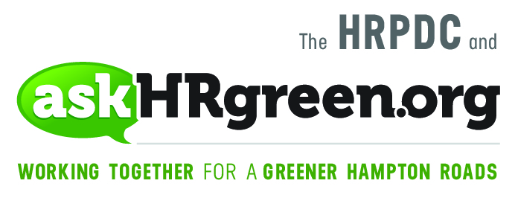

FOR IMMEDIATE RELEASE
Media Contacts:
Katie Cullipher, HRPDC Principal Environmental Education Planner
(757) 420-8300; kcullipher@hrpdcva.gov
Elizabeth Evans, Red Chalk Studios
(757) 705-7153; elizabeth@redchalkstudios.com

Setting a Green Holiday Table
How to host a gathering that is both joyous and gentle on the environment

(Hampton Roads, Nov. 15, 2018) – The gathering of family and friends over the holidays is a time-honored tradition, and nothing says “celebrate me home” more than sitting down with loved ones to a bountiful meal. This season, re-imagine your holiday feast by hosting one that will appeal to one of the most important family members of all – Mother Earth. From planning the menu to cooking and cleanup, the askHRgreen.org team offers these suggestions for hosting a celebration that is both joyous and gentle on the environment.

- The Menu – When planning the menu, consider how your food choices might support the Hampton Roads farming communities. Buying local keeps your dollars circulating here at home. Plus, fresh produce makes for a more delicious, nutritious meal. Our region is blessed with a diversity of farms, farmers markets, seafood stores and specialty shops, not to mention wineries and breweries, which source their food locally. Check the “Buy Local Hampton Roads” website for options near you.

- Shopping – With the menu squared away, it’s off to market. The first rule of thumb: BYOB – bring your own reusable bags. Take it a step further by avoiding the pull-off plastic bags in the produce area and placing your loose fruits and veggies in a string-net bag. As you’re shopping, look for foods with sustainable certification seals that show these items were produced in a socially and environmentally responsible way (like coffee, tea and chocolate). Earn more eco-wise points by avoiding products that are overly packaged.
- The Table – Having company to dinner is cause to bring out the china, crystal, silverware and cloth napkins. If you’re expecting a crowd, mix and match whatever dishes you have in a trendy, curated way. However you lay the table, avoid single-use plastics such as a disposable plates, utensils, tumblers and cups. These can’t be recycled, and it creates waste.

- Cooking – Now for the fun! As you peel potatoes and snap beans, have a large bowl nearby to toss in food scraps to be composted or thrown in the trash. Stuffing your garbage disposal with food, oily batter, poultry pieces and other scraps can really gum up your pipes. Next thing you know, you have a backed-up kitchen sink and an expensive visit from the plumber.

- Cleanup – The clean-up rule is simple: recycle what you can, and clean up responsibly. Wipe plates and serving containers with a paper towel before rinsing or washing in the sink, to avoid a kitchen sink backup. Pour any standing grease or leftover cooking oil into a can to freeze, before tossing safely in the trash. As for the vast amounts of oil used to fry a turkey, strain it, contain and reuse it, or check our listing of fryer oil collection sites by locality.

Feeling good about now? You should! It’s time for a brisk walk and a nap. Best wishes to you and yours for the holiday season ahead, from your friends at askHRgreen.org.

About askHRgreen.org
askHRgreen.org is your go-to resource for all things green in Hampton Roads – from recycling tips and pointers for keeping local waterways clean to water-saving ideas and simple steps to make local living easy on the environment. Launched in 2011, the region-wide public awareness and education campaign is administered through the Hampton Roads Planning District Commission and powered by the following members: The cities of Chesapeake, Franklin, Hampton, Newport News, Norfolk, Poquoson, Portsmouth, Suffolk, Virginia Beach, and Williamsburg; the counties of Gloucester, Isle of Wight, James City, Southampton, Surry and York; the town of Smithfield; and HRSD. Like askHRgreen.org on Facebook, follow on Twitter and Instagram, tune in to YouTube and catch the “Let’s Talk Green” blog, written by a team of local experts.

