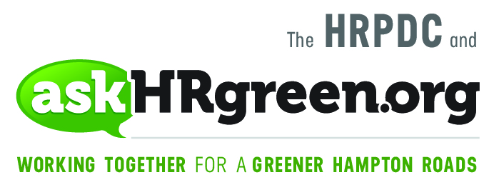

FOR IMMEDIATE RELEASE
Media Contacts:
Katie Cullipher, HRPDC Senior Environmental Education Planner
(757) 420-8300; kcullipher@hrpdcva.gov
Elizabeth Evans, Red Chalk Studios
(757) 705-7153; elizabeth@redchalkstudios.com

The Gift That Keeps on Giving –
Recycling Tips for Your Naturally-grown Christmas Tree

(Hampton Roads, Va., Dec. 26, 2018) – The end of the holidays doesn’t mean the end of your holiday decorations. Naturally-grown Christmas trees, fresh garland and other greenery can receive a second life when recycled or reused in your yard and garden. That’s a thoughtful way to extend the season of giving, according to Rebekah Eastep, team leader with askHRgreen.org.
“Recycling your Christmas tree keeps it out of the landfill and helps you give back to your community. Many localities collect and chip the trees into mulch or compost that is used to spruce up city and county parks, roadway plantings and median areas,” said Eastep.
Beginning on or around Dec. 26, residents throughout the greater Hampton Roads area may take advantage of this seasonal recycling program. Trees should be free of ornaments, tinsel or stands and placed at the curb on scheduled collection days or taken to a designated drop off location.
In addition to traditional recycling, there are many creative ways to give O Tanenbaum a second life by reusing natural Christmas trees, boughs and garland in your yard. You can try:
- Placing the tree in the yard with citrus peels and strung popcorn for the birds
- Shredding pines needles for use on pathways and trails
- Draping boughs and branches over plant beds for winter protection
- Using the tree as a habitat for wintering birds and woodland creatures
- Sinking branches into ornamental ponds to feed the fish
- Snipping small branches to use as kindling in fire pits
“Recycling and reusing your holiday greenery is truly the gift that keeps on giving,” said Eastep.
As of this date, the following cities and counties have announced their natural Christmas tree recycling/pick-up schedules. Contact your locality or visit their website for updates. For additional information about all things green, go to http://askhrgreen.org/2019-christmas-tree-schedule/

About askHRgreen.org
askHRgreen.org is your go-to resource for all things green in Hampton Roads – from recycling tips and pointers for keeping local waterways clean to water-saving ideas and simple steps to make local living easy on the environment. Launched in 2011, the region-wide public awareness and education campaign is administered through the Hampton Roads Planning District Commission and powered by the following members: The cities of Chesapeake, Franklin, Hampton, Newport News, Norfolk, Poquoson, Portsmouth, Suffolk, Virginia Beach, and Williamsburg; the counties of Gloucester, Isle of Wight, James City, Southampton, Surry and York; the town of Smithfield; and HRSD. Like askHRgreen.org on Facebook, follow on Twitter and Instagram, tune in to YouTube and catch the “Let’s Talk Green” blog, written by a team of local experts.

